Digital Chip Design Program
RTL Design
Alia Alsultan
Elaf Alkhalaf
Lana Aldhali
Manar Alnuqaydan

Task #10
20/07/2026

Seq & Comb Circuits Datapath – Part 1

Task #10.1

10.1.1

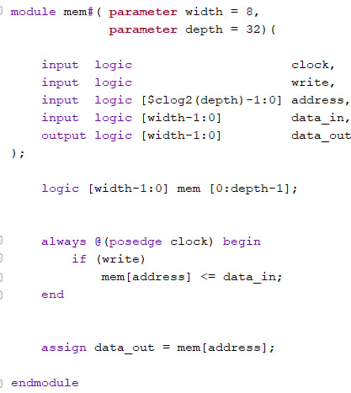

10.1.2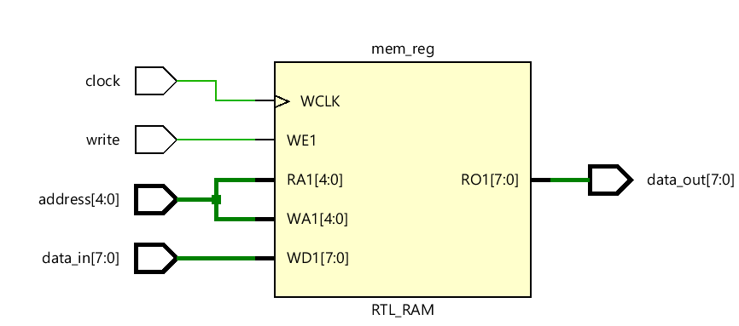

10.1.3

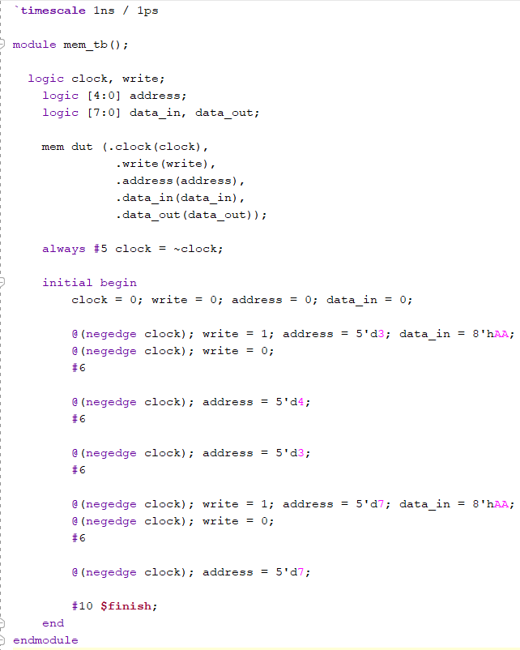

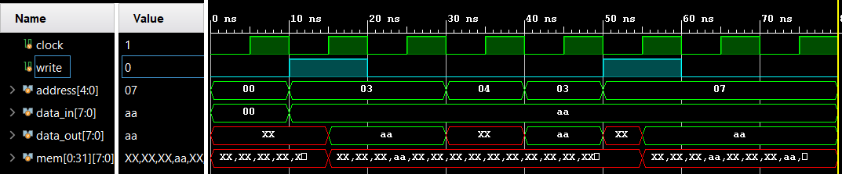

Work distribution

Section | Alia | Elaf | Lana | Manar
Report | ✔ | ✔ | ✔ | ✔
Task 10.1.1 | ✔ | ✔ | ✔ | ✔
Task 10.1.2 | ✔ | ✔ | ✔ | ✔
Task 10.1.3 | ✔ | ✔ | ✔ | ✔

